**CS5590 Big Data**

**Lab 2 Assignment**

Adt bundle was used to develop the android application.

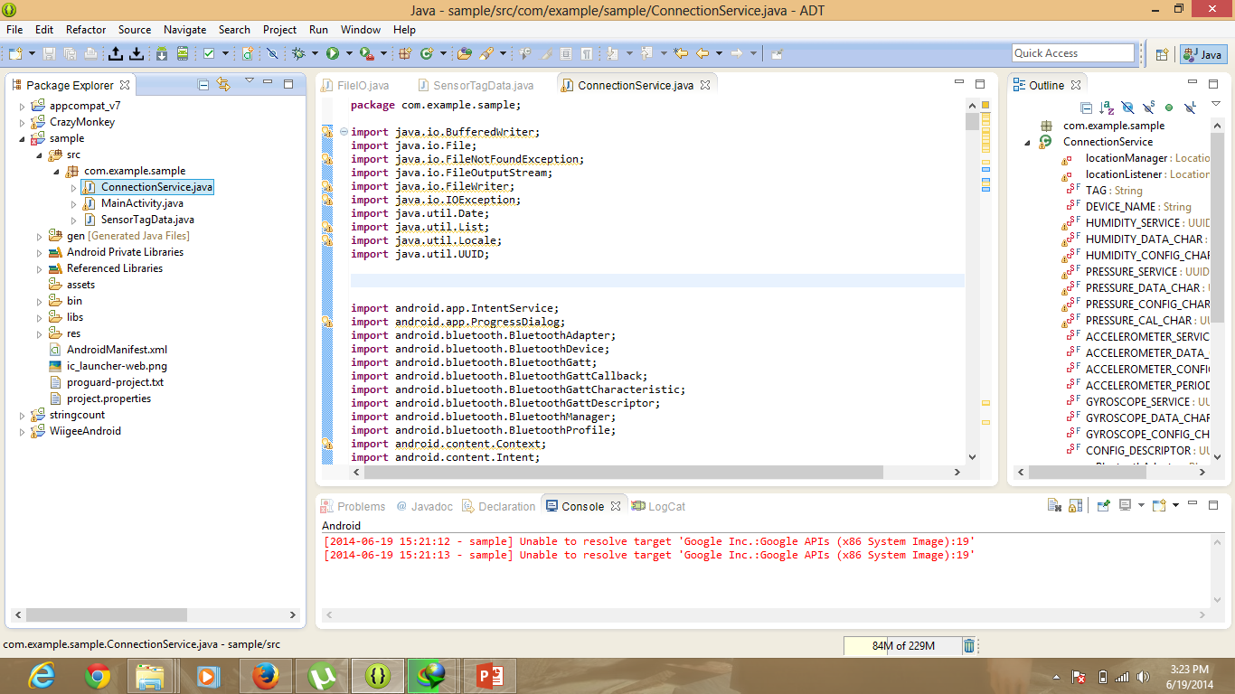

Code was modified to find the Accelerometer, humidity, gyroscope, date values. 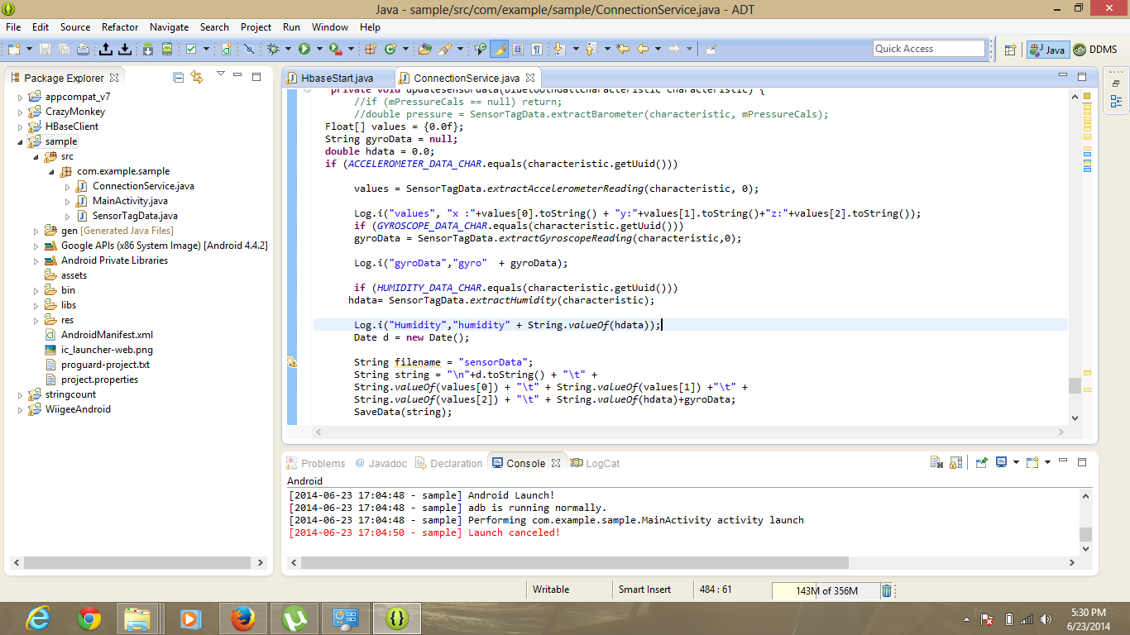

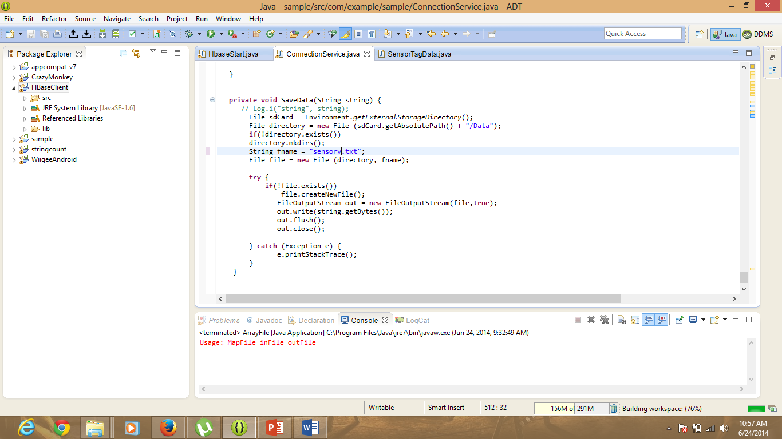

All the data retrieved from the sensors is saved in the sensorv.txt file on the sdcard of the tablet used.

The file was copied from phone to the computer.

The layout the app is such the it has a button whenever the button is pressed the sensors start working.

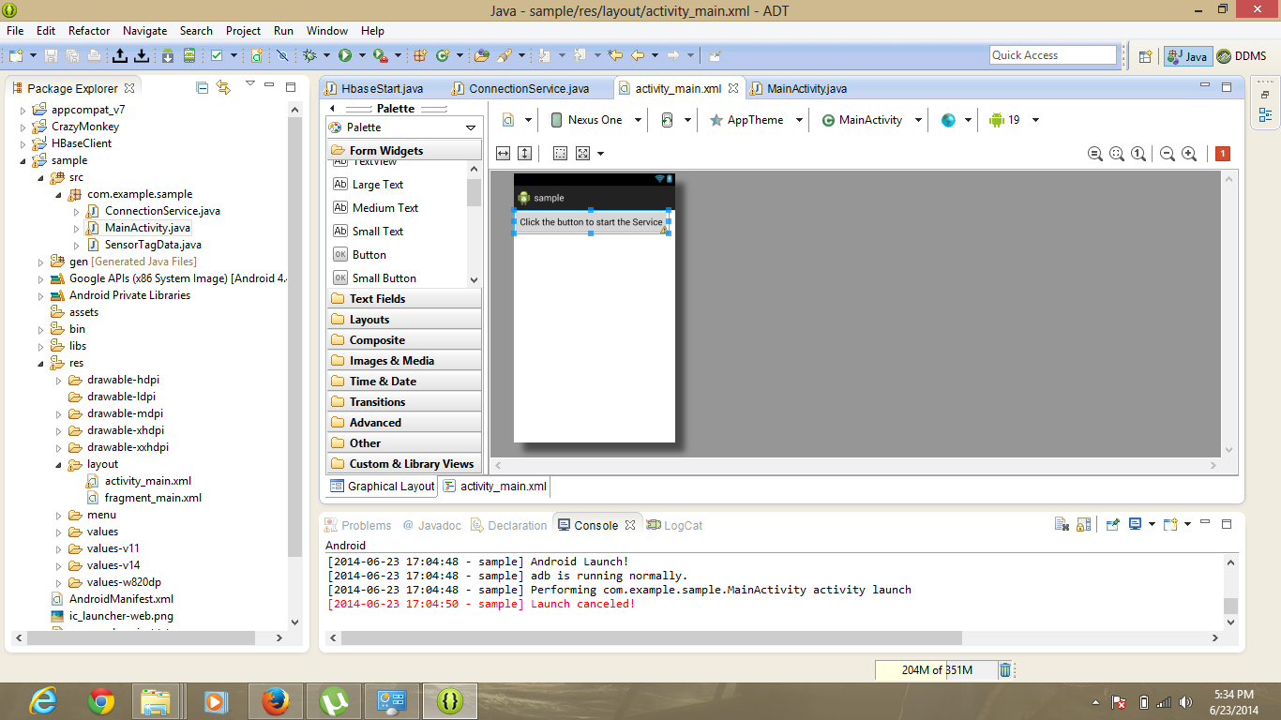

The app is run in debugging mode of the phone/tablet and the logs are seen in the logcat view of the eclipse.

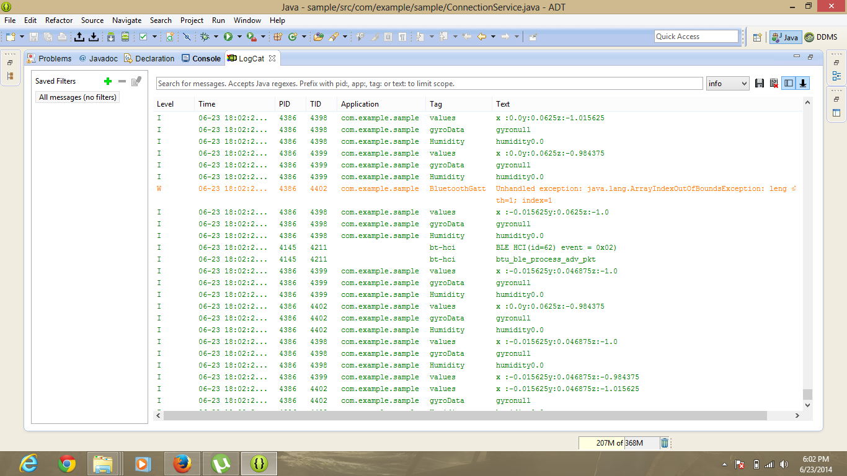

The data can be found on the phone sdcard.

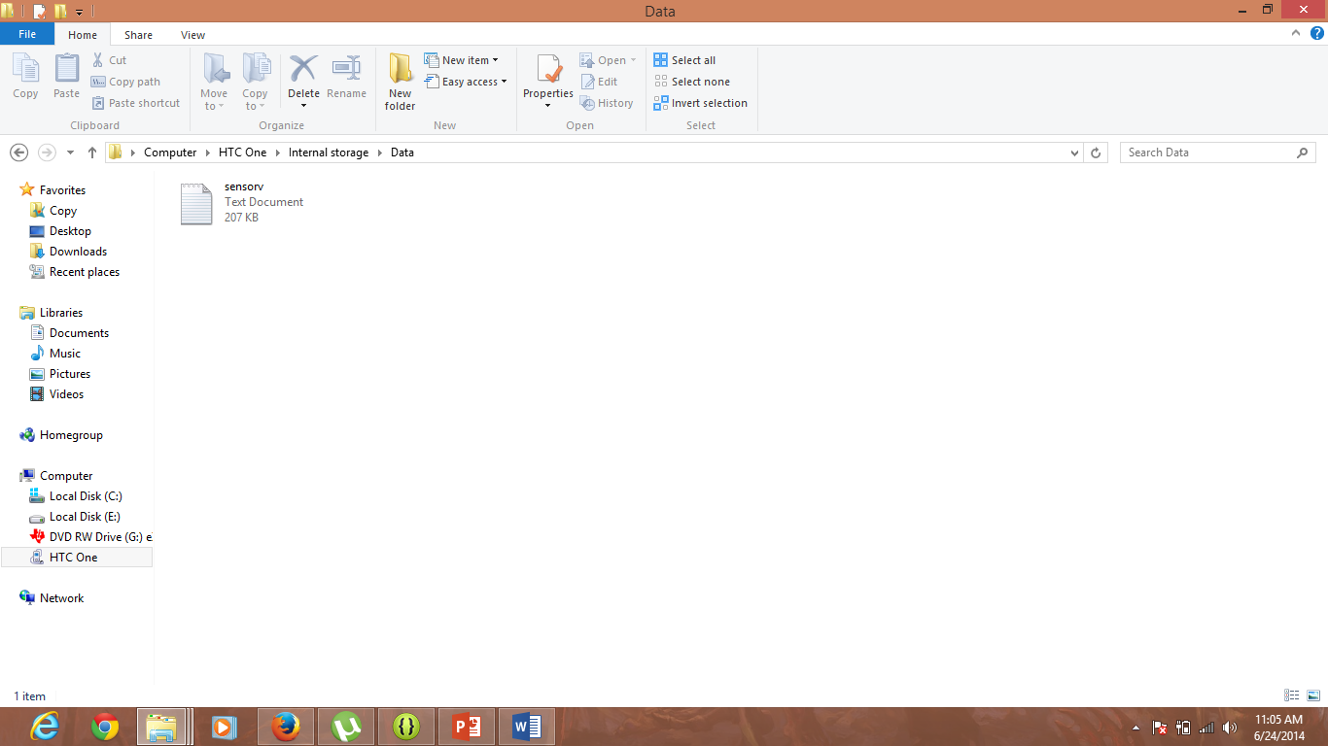

Now, the table with required columns were created in the hbase using the hbase client.

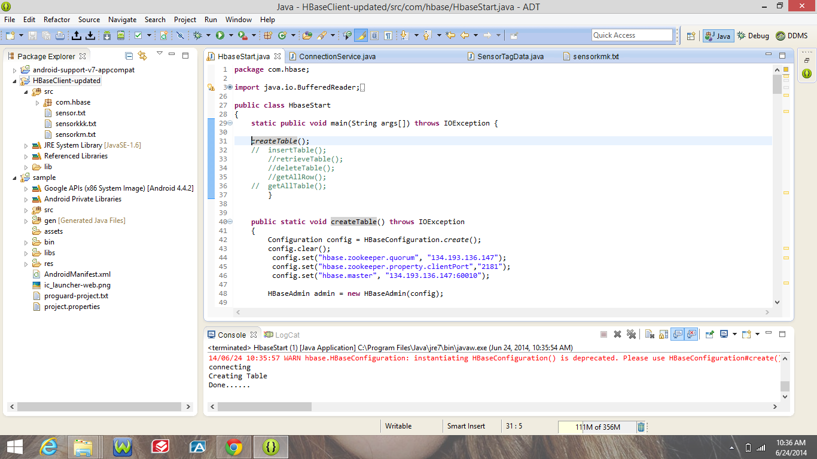

The created table can be seen in the Cloudera site.

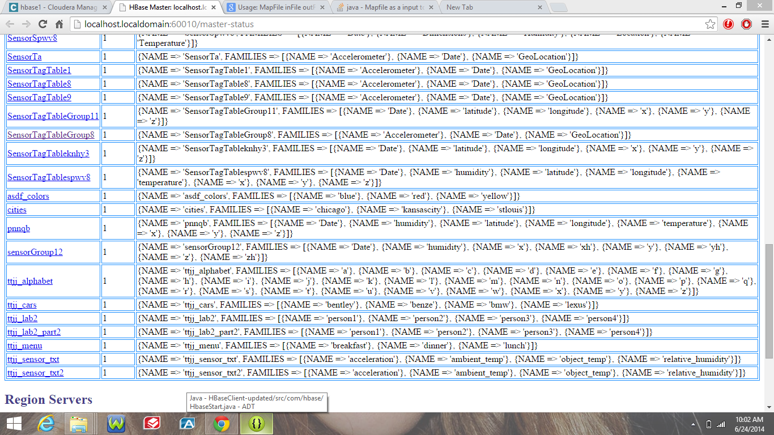

Now the insert function is run.

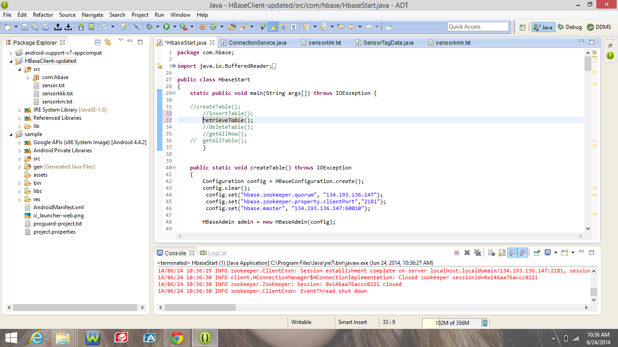

Now the retrieve function is run.

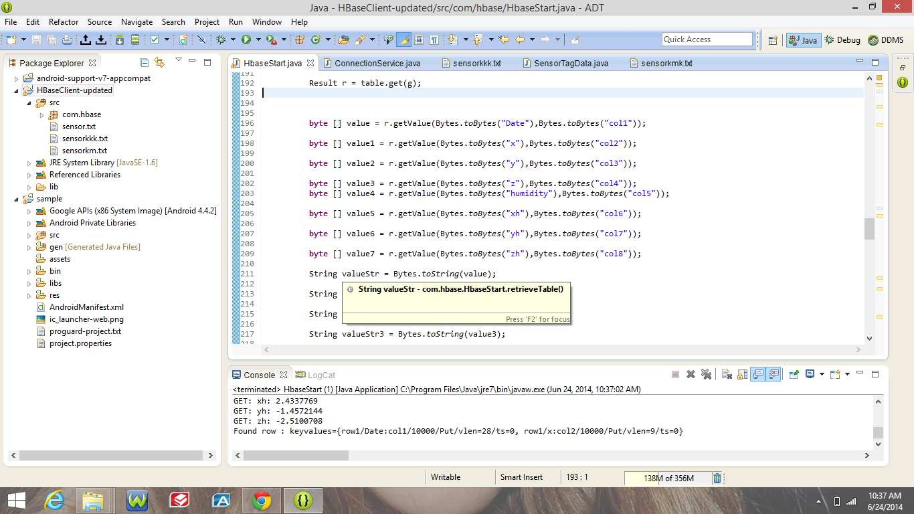

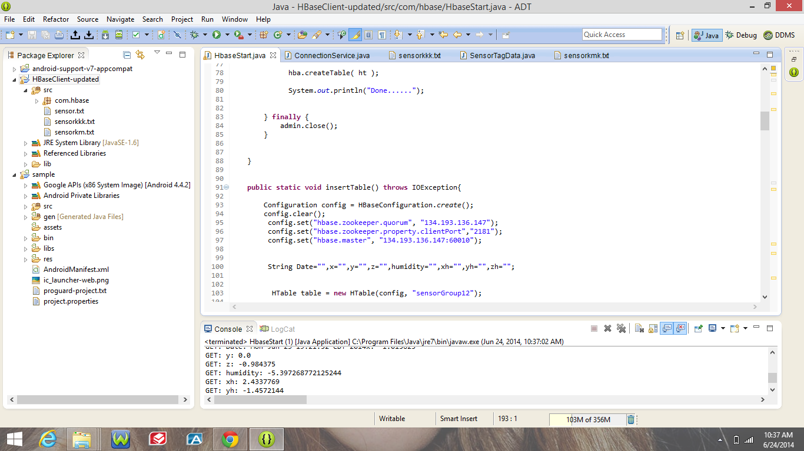

After the retrieving is done the table is deleted using the delete function.

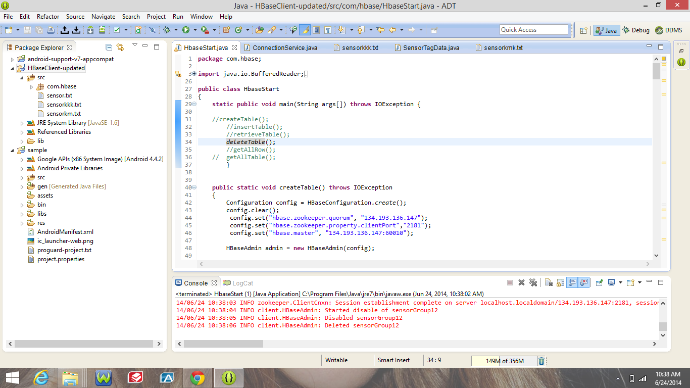

Get all rows function can also be used.

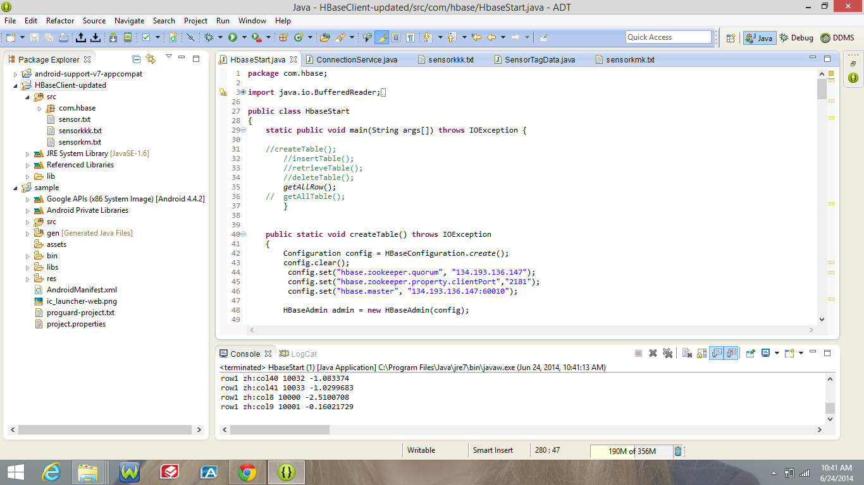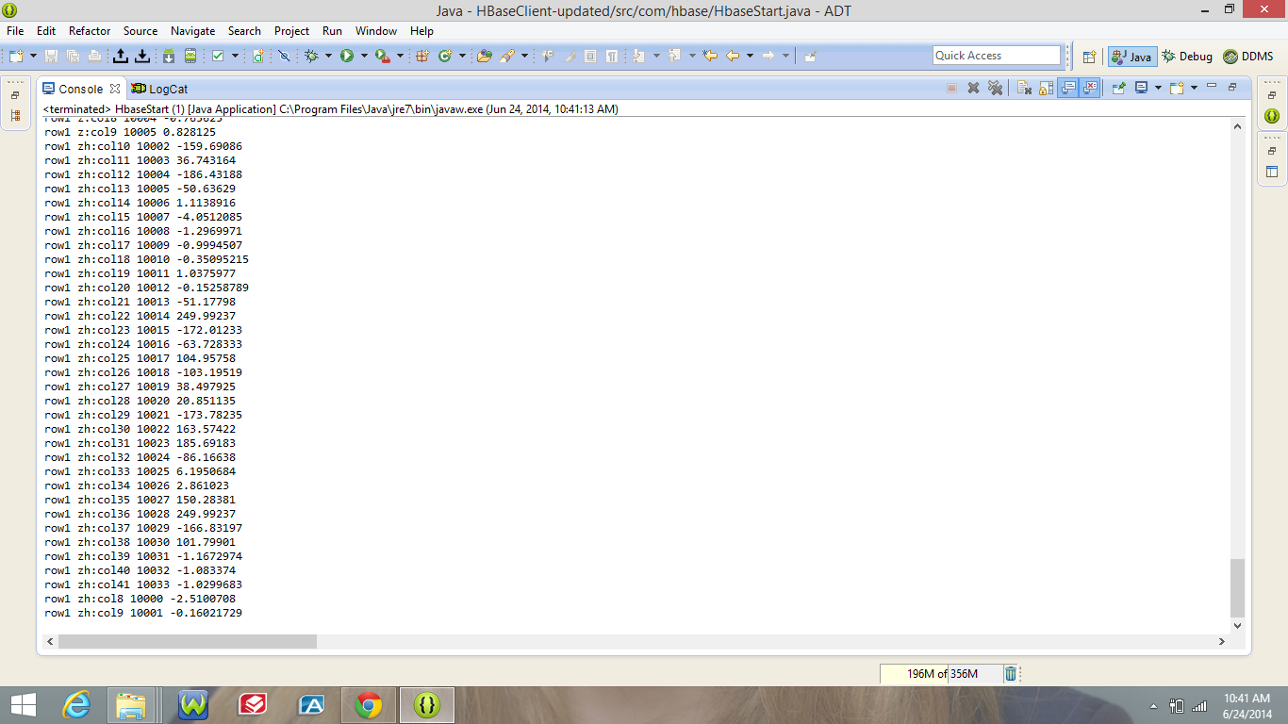

**Sree Vishnu Satarajupalli**

**16162426**

**Sshy3@mail.umkc.edu**